White Ribbon Ride  2026 ITINERARY | 

White Ribbon Ride North Island
Palmerston North to Wellington

Sunday 22 to Saturday 28 November 2026

^{DRAFT As at 9 October 2026}
RIDE INFO
JOINING THE RIDE Anyone can join the Ride for as long as they wish, as long as they abide by the Ride Rules as outlined below | This map is a guide only and includes the general ride destinations, not specific locations. Please note that the route may change at the last minute due to unforeseen circumstances  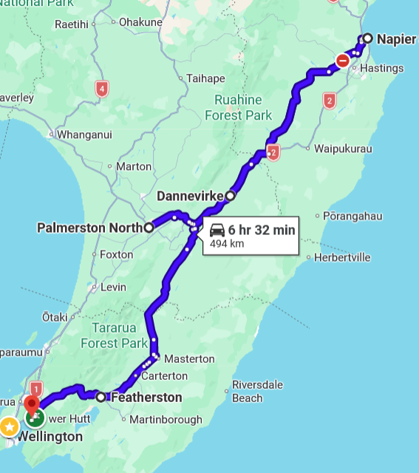
COST There is no registration fee; your cost is your time, petrol and accommodation.
TO BRING Current driver’s license, warranted, registered and insured bike with minimum 250cc engine size (except in city limits), full face helmet and visor, puncture repair kit, wooden block for parking on grass, windscreen cleaning gear, torch, warm/windproof/wet weather riding gear, (here is a handy list of other items you may need), sleeping bag, pillow, towel, sunscreen, lip balm, toiletries, ear plugs, camera, an adventurous spirit and a will to end violence in New Zealand communities. Excess items may be carried in the support vehicle.
The Ride Leaders will carry medical kits.
ACCOMMODATION is generally on marae. To stay with the riders you must let us know as soon as possible by emailing ride@whiteribbon.org.nz.
RIDE RULES No alcohol or drugs permitted on the Ride
No gang patches, No Rockers
Motorcycle must be of 250cc or larger (except in city limits)
The White Ribbon Riders are responsible for on-road safety and protocol
By taking part, you agree to “stand up, speak out and act to prevent men’s violence towards women”
CASUAL RIDERS Any casual riders must contact the Ride Leader to arrange a meeting place and time.

RIDE LEADER | 027 499 3393 | Takurua Tawera
RIDE CAPTAIN | 021 546 653 | Tame Ngaheke
SUPPORT CREW | 0272 942 517 | Cathy Tawera
RIDE COORDINATOR | 027 645 8872 | Jocelyn Smith ride@whiteribbon.org.nz

North Island 2026
SAT  21 NOV | Positioning Ride to Palmerston North
SAT  21 NOV | ACCOMM | 1630 | St Michael's Anglican Church & Marae  70 Ellesmere Crescent, Palmerston North
SUN  22 NOV  Palmerston North  KM  Time | EVENT | TIME | LOCATION | DEPART TO | ROUTE/DISTANCE/TRAVEL TIME
SUN  22 NOV  Palmerston North  KM  Time | DEPART ACCOMM | 1030 | St Michaels  70 Ellesmere Cres, Palmerston North
SUN  22 NOV  Palmerston North  KM  Time | EVENT | 1100 | Palmerston North
SUN  22 NOV  Palmerston North  KM  Time | EVENT | 1500 | Private Youth Event  Palmerston North
SUN  22 NOV  Palmerston North  KM  Time | ACCOMM | 1730 | St Michaels  70 Ellesmere Cres, Palmerston North
MON  23 NOV  Palmerston North  To Napier  KM  Time | EVENT | TIME | LOCATION | DEPART TO | ROUTE/DISTANCE/TRAVEL TIME
MON  23 NOV  Palmerston North  To Napier  KM  Time | DEPART ACCOMM |  | St Michaels  70 Ellesmere Cres, Palmerston North
MON  23 NOV  Palmerston North  To Napier  KM  Time | EVENT |  | Dannevirke TBC
MON  23 NOV  Palmerston North  To Napier  KM  Time | ARRIVE ACCOMM |  | 2 Faraday Street  Napier City
TUES  24 NOV  In Napier  KM  Time | EVENT | TIME | LOCATION | DEPART TO | ROUTE/DISTANCE/TRAVEL TIME
TUES  24 NOV  In Napier  KM  Time | DEPART ACCOMM |  | 2 Faraday Street  Napier City |  | SH2 | 48 Km |  | 45 Mins
TUES  24 NOV  In Napier  KM  Time | EVENT | 1030 | Te Aute College  100 SH2, Pukehou
TUES  24 NOV  In Napier  KM  Time | EVENT | 1230 | Tamatea High School  61 Freyberg Avenue, Napier
TUES  24 NOV  In Napier  KM  Time | EVENT | 1345 | William Colenso College  21 Arnold Street, Napier
TUES  24 NOV  In Napier  KM  Time | ARRIVE ACCOMM |  | 2 Faraday Street  Napier City
WED  25 NOV  White Ribbon Day  In Napier  /Hastings  To Dannevirke  KM  Time | EVENT | TIME | LOCATION | DEPART TO | ROUTE/DISTANCE/TRAVEL TIME
 | DEPART ACCOMM |  | 2 Faraday Street  Napier City
 | EVENT |  | Hastings TBC
 | EVENT | 1100 | Napier Soundshell  70 Marine Parade, Napier South
 | ARRIVE ACCOMM |  | Makirikiri Marae  23 Mākirikiri Road, Dannevirke
THURS  26 NOV  Dannevirke  To Te Awa Kairangi, Lower Hutt  KM  Time | EVENT | TIME | LOCATION | DEPART TO | ROUTE/DISTANCE/TRAVEL TIME
 | DEPART ACCOMM |  | Makirikiri Marae  23 Mākirikiri Road, Dannevirke
 | EVENT |  | Tararua College  Churchill Street, Pahiatua |  |  | 99 KM |  | 1 HR 30 Mins
 | EVENT |  | Featherston School  11 Lyon Street, Featherston |  |  | 51 KM |  | 1 Hour
 | ARRIVE ACCOMM | 1630 | Waiwhetu Marae  21 Puketapu Grove, Waiwhetu
FRI  27 NOV  In Te Awa Kairangi, Lower Hutt | EVENT | TIME | LOCATION | DEPART TO | ROUTE/DISTANCE/TRAVEL TIME
FRI  27 NOV  In Te Awa Kairangi, Lower Hutt | DEPART ACCOMM |  | Waiwhetu Marae
FRI  27 NOV  In Te Awa Kairangi, Lower Hutt | EVENT | 0930 | Naenae Primary School
FRI  27 NOV  In Te Awa Kairangi, Lower Hutt | EVENT |  | Epuni TBC
FRI  27 NOV  In Te Awa Kairangi, Lower Hutt | EVENT |  | TBA
FRI  27 NOV  In Te Awa Kairangi, Lower Hutt | EVENT |  | Debrief
SAT  28 NOV  Te Awa Kairangi | EVENT | TIME | LOCATION | DEPART TO | ROUTE/DISTANCE/TRAVEL TIME
SAT  28 NOV  Te Awa Kairangi |  |  | Breakfast/Home
END OF RIDE

