White Ribbon Ride  2025 ITINERARY | 

White Ribbon Ride North Island
Palmerston North to Whanganui

Saturday 22 to Friday 28 November 2025

^{As at 12 November 2025}
RIDE INFO
JOINING THE RIDE Anyone can join the Ride for as long as they wish, as long as they abide by the Ride Rules as outlined below | This map is a guide only and includes the general ride destinations, not specific locations. Please note that the route may change at the last minute due to unforeseen circumstances  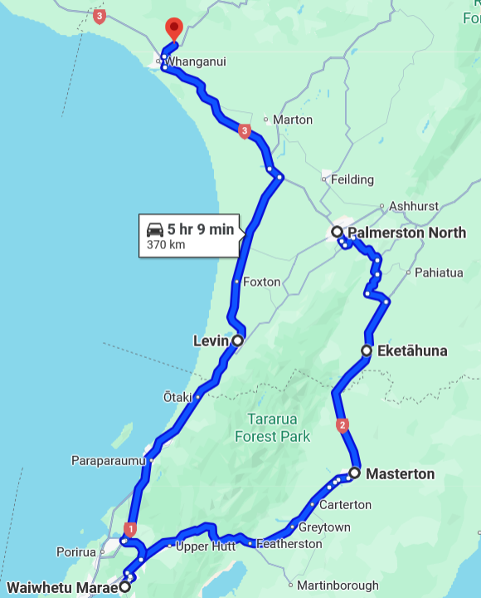
COST There is no registration fee; your cost is your time, petrol and accommodation.
TO BRING Current driver’s license, warranted, registered and insured bike with minimum 250cc engine size (except in city limits), full face helmet and visor, puncture repair kit, wooden block for parking on grass, windscreen cleaning gear, torch, warm/windproof/wet weather riding gear, (here is a handy list of other items you may need), sleeping bag, pillow, towel, sunscreen, lip balm, toiletries, ear plugs, camera, an adventurous spirit and a will to end violence in New Zealand communities. Excess items may be carried in the support vehicle.
The Ride Leaders will carry medical kits.
ACCOMMODATION is a combination of marae, army/navy bases and holiday parks. To stay with the riders you must let us know as soon as possible by emailing ride@whiteribbon.org.nz.
Accommodation cannot be provided in all cases and usually costs a set fee of $25 per night including an evening meal. You must contact us to have this option approved as it is strictly limited.
RIDE RULES No alcohol or drugs permitted on the Ride
No gang patches, No Rockers
Motorcycle must be of 250cc or larger (except in city limits)
The White Ribbon Riders are responsible for on-road safety and protocol
By taking part, you agree to “stand up, speak out and act to prevent men’s violence towards women”
CASUAL RIDERS Any casual riders must contact the Ride Leader to arrange a meeting place and time.

RIDE LEADER | 027 499 3393 | Takurua Tawera
RIDE CAPTAIN | 027 242 3347 | Dempsey Broad
SUPPORT CREW | 0272 942 517 | Cathy Tawera
RIDE COORDINATOR | 027 645 8872 | Jocelyn Smith ride@whiteribbon.org.nz

North Island 2025
SAT  22 NOV | Positioning Ride to Feilding
SAT  22 NOV | ACCOMM | 1630 | Kauwhata Marae  148A Te Arakura Road, Feilding
SUN  23 NOV  Feilding  Palmerston North  22Km  30 Mins | EVENT | TIME | LOCATION | DEPART TO | ROUTE/DISTANCE/TRAVEL TIME
SUN  23 NOV  Feilding  Palmerston North  22Km  30 Mins | DEPART ACCOMM | 1030 | Kauwhata Marae  148A Te Arakura Road, Feilding | Ross Intermediate | SH54, Milson Line | 11KM |  | 15 Mins
SUN  23 NOV  Feilding  Palmerston North  22Km  30 Mins | EVENT | 1100 |  | Feilding | Milson Line, SH54 | 11KM |  | 15 Mins
  Ross Intermediate School
  25 Freyberg Street, Palmerston North
SUN  23 NOV  Feilding  Palmerston North  22Km  30 Mins | EVENT | 1730 | Kauwhata Marae  148A Te Arakura Road, Feilding
SUN  23 NOV  Feilding  Palmerston North  22Km  30 Mins | EVENT | 1900 | Kauwhata Marae  148A Te Arakura Road, Feilding
SUN  23 NOV  Feilding  Palmerston North  22Km  30 Mins | ACCOMM |  | Kauwhata Marae  148A Te Arakura Road, Feilding
MON  24 NOV  Feilding  Via Masterton  To Lower Hutt  240 KM  4 Hours | EVENT | TIME | LOCATION | DEPART TO | ROUTE/DISTANCE/TRAVEL TIME
 | DEPART ACCOMM | 0730 | Kauwhata Marae | Eketāhuna | SH3/SH2 | 112 KM |  | 1 Hr 30 Mins
 | EVENT | 0900 | Eketahuna Inn  42 Main Street, Eketahuna | Masterton | SH2 | 40 Km |  | 30 Mins
 | EVENT | 1115 | Wairarapa College  83 Pownall Street, Masterton | Makoura College |  | 2.5 KM |  | 10 Mins
 | EVENT | 1230 TBC | Mākoura College  Mākoura Rd, Masterton | Featherston |  | 36 Km |  | 45 Mins
 | EVENT | 1415 | Featherston School  11 Lyon Street, Featherston | Waiwhetu |  | 51 Km |  | 1 Hour
 | ARRIVE ACCOMM | 1630 | Waiwhetu Marae  21 Puketapu Grove, Waiwhetu
TUES  25 NOV  White Ribbon Day  In Lower Hutt  24 Km  50 Mins | EVENT | TIME | LOCATION | DEPART TO | ROUTE/DISTANCE/TRAVEL TIME
 | DEPART ACCOMM | 0930 | Waiwhetu Marae | 11-27 Victoria Street |  | 4 Km |  | 10 Mins
 | EVENT | 0945 | Te Ara Whānui Kura Kaupapa Māori  11-27 Victoria Street Alicetown | Naenae Primary School |  | 6 Km |  | 15 Mins
 | EVENT | 1215 | Naenae Primary School  Waddington Drive, Naenae | Wainuiomata High School |  | 9 Km |  | 15 Mins
 | EVENT | 1315 TBC | Wainuiomata High School  Parkway, Wainuiomata | Waiwhetu |  | 5 Km |  | 10 Mins
 | ARRIVE ACCOMM |  | Waiwhetu Marae
WED  26 NOV  Lower Hutt  To  Whanganui  193 Km  3 Hours | EVENT | TIME | LOCATION | DEPART TO | ROUTE/DISTANCE/TRAVEL TIME
WED  26 NOV  Lower Hutt  To  Whanganui  193 Km  3 Hours | DEPART ACCOMM | 0900 | Waiwhetu Marae | Levin | SH58, SH1 | 87 Km |  | 1H 15 Mins
WED  26 NOV  Lower Hutt  To  Whanganui  193 Km  3 Hours | EVENT | 1030 | Manakau School  9 Mokena Kohere St | Foxton | SH1 | 18 Km |  | 20 Mins
WED  26 NOV  Lower Hutt  To  Whanganui  193 Km  3 Hours | EVENT | 1230 | Foxton Heartland Service Centre  9 Lady’s Mile, Foxton | Whanganui | SH1, SH3 | 88 Km |  | 1 Hr 20 Mins
WED  26 NOV  Lower Hutt  To  Whanganui  193 Km  3 Hours | ARRIVE ACCOMM | 1630 | Te Ao Hou Marae  356 Somme Parade, Whanganui
THURS  27 NOV  Whanganui | EVENT | TIME | LOCATION | DEPART TO | ROUTE/DISTANCE/TRAVEL TIME
THURS  27 NOV  Whanganui | DEPART ACCOMM | 1000 | Te Ao Hou Marae | Keith Street School |  | 5 Km |  | 10 Mins
THURS  27 NOV  Whanganui | EVENT | 1030 | Keith Street School  38-46 Keith Street, Whanganui | Rutherford Intermediate | Liverpool St, Grey St | 3.4km |  | 10 Mins
THURS  27 NOV  Whanganui | EVENT | 1200 | Rutherford Intermediate  32 Toi St | Te Ao Hou Marae | Glasgow St  Somme P’de | 7.5 Km |  | 15 Mins
THURS  27 NOV  Whanganui | ARRIVE ACCOMM |  | Te Ao Hou Marae
FRI  28 NOV  Whanganui | EVENT | TIME | LOCATION | DEPART TO | ROUTE/DISTANCE/TRAVEL TIME
FRI  28 NOV  Whanganui | DEPART ACCOMM | 0900 | Te Ao Hou Marae | Te Kura o Kokohuia | Somme P’de | 9.5Km | 15 Mins
FRI  28 NOV  Whanganui | EVENT | 0930 | Te Kura o Kokohuia,  36 Matipo Street, Castlecliff | Pakaitore | Puriri St  Alma Rd | 5.5 Km | 10 Mins
FRI  28 NOV  Whanganui | EVENT | 1200 | Hikoi of hope  Pakaitore to War Memorial Centre
FRI  28 NOV  Whanganui | END OF RIDE

