WHITE RIBBON RIDE EVENT IDEAS

To get you inspired, we have put together some event ideas from previous Rides:

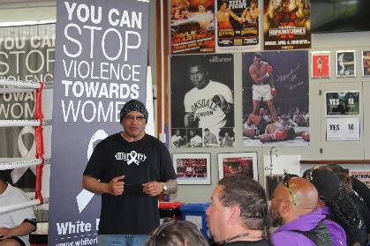
Panel discussion
Riders told their stories then fielded questions/comments from the audience. This event was interactive, thought-provoking, and really well received by the community.
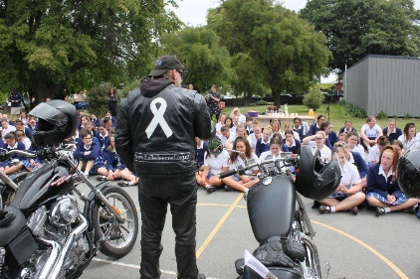

School visits
The Riders have visited a vast array of schools where they captivated the children with their bikes and messages. The messaging resonated, with kids being told to ‘be awesome to each other, especially your mums, sisters and friends’, and that bullying was not cool.

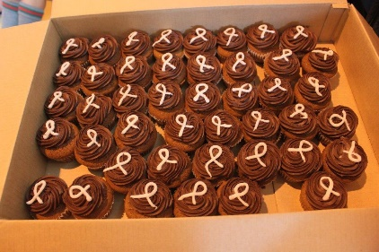

Baking
There has been an array of home cooking at events and many of the items helped to spread the message with effective use of the White Ribbon logo. We even sell a logo-shaped cookie cutter on our website.

Giant Ribbons
An aerial photo was taken of a hundred school children holding sheets of white paper above their heads, standing in the shape of a ribbon. After listening to the Riders speak, they knew exactly what the day was about and the photo looked great in the newspapers. We have also made a giant White Ribbon, which holds signatures and stories. We can arrange to have this delivered and displayed in your community. You could also create your own.

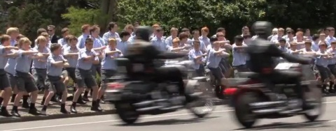
White Ribbon Rolling Haka
Schools joined together to form a rolling haka which sent shivers down even the most jaded spines. The schools utilised the opportunity to incorporate the White Ribbon kaupapa.

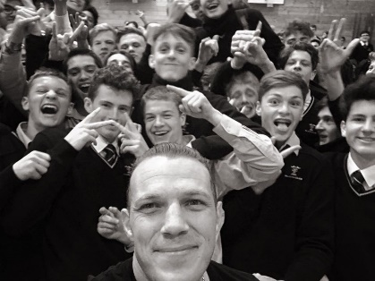

Ambassadors
We have a large number of Ambassadors who are willing to support the Riders on their mission. If you don’t know if your community has one, please get in touch with us at contact@whiteribbon.org.nz.

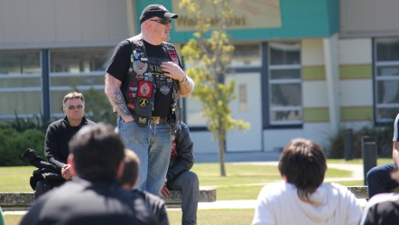
Prison visits
Corrections facilities have invited the Riders into their midst to speak with high-risk inmates. Emotive scenes unfolded, with passionate hakas offered in support of the kaupapa and poignant stories shared between the riders and the inmates.

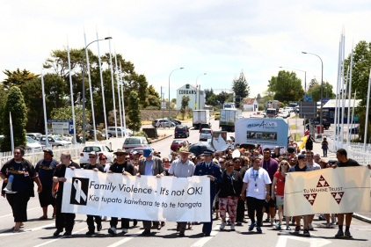
There were many more highlights with marches, breakfasts, sporting events, family fun days, Dads and sons events, tug of wars, gumboot races, walk a mile in her shoes, speaking engagements and of course many opportunities where men, women and children were able to meet the riders and share the kaupapa (and of course sit on the awesome bikes).

You could organise for the audience to take The Pledge to ‘stand up, speak out and act to prevent men’s violence towards women’ and we have resources available at our online shop.

